2017 HOLIDAY SHIPPING TIMELINES
From American Canyon, CA (WDI)

HAPPY HOLIDAYS! In order to ensure a timely consumer delivery during the busy holiday season, we have provided recommended last order submission dates below for packages to arrive in time. During this busy season of the year, WineDirect will maintain our standard order cutoff time of 1pm to give you as much time as possible to process orders. Please note that carriers are suspending the guarantee of published transit times during the holiday peak times.
Below are the recommended LAST ORDER SUBMISSION DATES
to ship from the AMERICAN CANYON, CA facility:

SERVICE | TIME IN TRANSIT |   THANKSGIVING |   CHRISTMAS |   NEW YEARS
Ground & Overnight | 1 Day | 11/20 | 12/20 | 12/27
Ground & 2-Day | 2 Days | 11/17 | 12/19 | 12/26
Ground | 3 Days | 11/16 | 12/18 | 12/22
Ground | 4 Days | 11/15 | 12/15 | 12/21
Ground | 5 Days | 11/14 | 12/14 | 12/20
Ground | 6 Days | 11/13 | 12/13 | 12/19
Ground | 7 Days | 11/10 | 12/10 | 12/18
3-Tier – FL | 7 Days leaves Fri | 11/9 | 12/7 | 12/14
3-Tier – NJ | 10 Days leaves Fri | 11/9 | 12/7 | 12/14
WineDirect Holiday Hours |  | Closed 11/23  Open 11/24 | Open ½ Day 12/22  Closed 12/25 | Open ½ Day 12/29  Closed 1/1

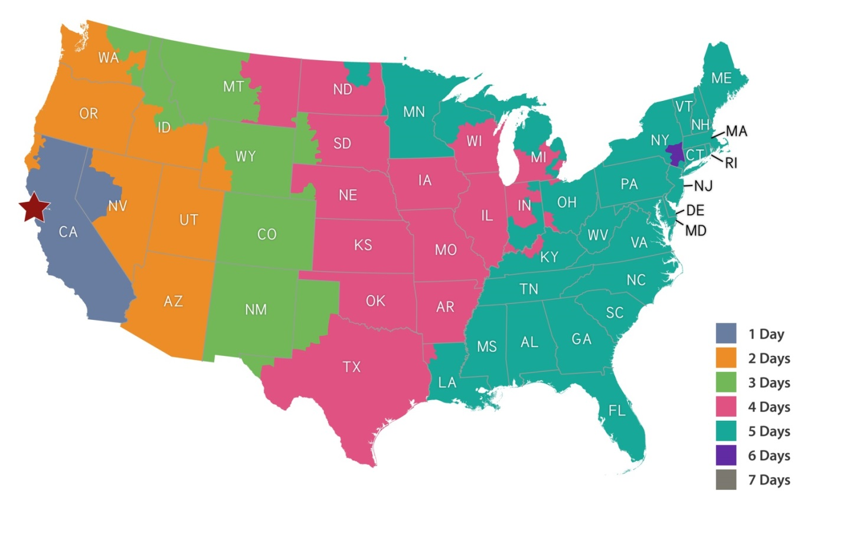
Time in Transit maps listed are for our preferred carrier UPS.
2017 HOLIDAY SHIPPING TIMELINES
BI-COASTAL: AMerican Canyon, CA & Glenwillow, OH

HAPPY HOLIDAYS! In order to ensure a timely consumer delivery during the busy holiday season, we have provided recommended last order submission dates below for packages to arrive in time. During this busy season of the year, WineDirect will maintain our standard order cutoff time of 1pm to give you as much time as possible to process orders. Please note that carriers are suspending the guarantee of published transit times during the holiday peak times.
Below are the recommended LAST ORDER SUBMISSION DATES
to ship from the AMERICAN CANYON, CA & GLENWILLOW, OH facilities:

SERVICE | TIME IN TRANSIT | THANKSGIVING | CHRISTMAS | NEW YEARS
Ground & Overnight | 1 Day | 11/20 | 12/20 | 12/27
Ground & 2-Day | 2 Days | 11/17 | 12/19 | 12/26
Ground | 3 Days | 11/16 | 12/18 | 12/22
Ground | 4 Days | 11/15 | 12/15 | 12/21
Ground | 5 Days | 11/14 | 12/14 | 12/20
Ground | 6 Days | 11/13 | 12/13 | 12/19
Ground | 7 Days | 11/10 | 12/10 | 12/18
3-Tier – FL (from WDI) | 7 Days leaves Fri | 11/9 | 12/7 | 12/14
3-Tier – NJ (from WDI) | 10 Days leaves Fri | 11/9 | 12/7 | 12/14
3-Tier – NJ (from GLW) | 5 Days leaves Wed | 11/14 | 12/12 | 12/19
WineDirect Holiday Hours |  | Closed 11/23  Open 11/24 | Open ½ Day 12/22  Closed 12/25 | Open ½ Day 12/29  Closed 1/1

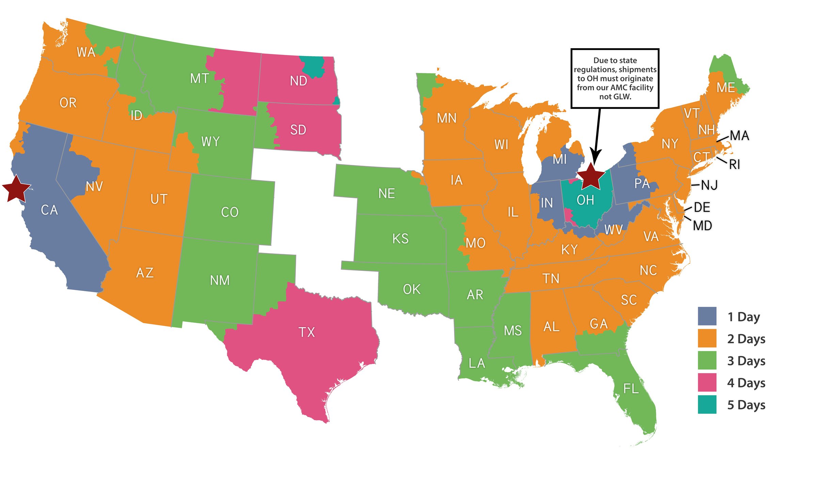
Time in Transit maps listed are for our preferred carrier UPS.
2017 HOLIDAY SHIPPING TIMELINES
From GLENWILLOW, OH (GLW)

HAPPY HOLIDAYS! In order to ensure a timely consumer delivery during the busy holiday season, we have provided recommended last order submission dates below for packages to arrive in time. During this busy season of the year, WineDirect will maintain our standard order cutoff time of 1pm to give you as much time as possible to process orders. Please note that carriers are suspending the guarantee of published transit times during the holiday peak times.
Below are the recommended LAST ORDER SUBMISSION DATES
to ship from the GLENWILLOW, OH facility:

SERVICE | TIME IN TRANSIT | THANKSGIVING | CHRISTMAS | NEW YEARS
Ground & Overnight | 1 Day | 11/20 | 12/20 | 12/27
Ground & 2-Day | 2 Days | 11/17 | 12/19 | 12/26
Ground | 3 Days | 11/16 | 12/18 | 12/22
Ground | 4 Days | 11/15 | 12/15 | 12/21
Ground | 5 Days | 11/14 | 12/14 | 12/20
Ground | 6 Days | 11/13 | 12/13 | 12/19
Ground | 7 Days | 11/10 | 12/10 | 12/18
3-Tier – NJ | 5 Days leaves Wed | 11/14 | 12/12 | 12/19
WineDirect Holiday Hours |  | Closed 11/23  Open 11/24 | Open ½ Day 12/22  Closed 12/25 | Open ½ Day 12/29  Closed 1/1

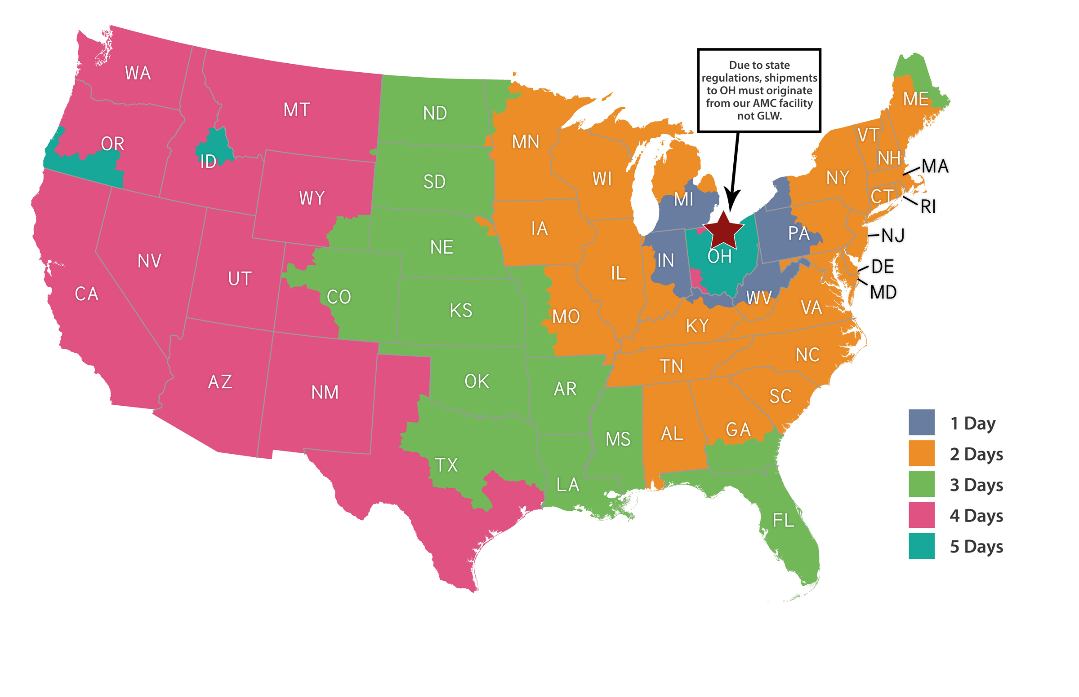
Time in Transit maps listed are for our preferred carrier UPS.

2017 HOLIDAY SHIPPING TIMELINES
From PASO RoBLES, CA (PSO)

HAPPY HOLIDAYS! In order to ensure a timely consumer delivery during the busy holiday season, we have provided recommended last order submission dates below for packages to arrive in time. During this busy season of the year, WineDirect will maintain our standard order cutoff time of 1pm to give you as much time as possible to process orders. Please note that carriers are suspending the guarantee of published transit times during the holiday peak times.
Below are the recommended LAST ORDER SUBMISSION DATES
to ship from the PASO ROBLES, CA facility:

SERVICE | TIME IN TRANSIT | THANKSGIVING | CHRISTMAS | NEW YEARS
Ground & Overnight | 1 Day | 11/20 | 12/20 | 12/27
Ground & 2-Day | 2 Days | 11/17 | 12/19 | 12/26
Ground | 3 Days | 11/16 | 12/18 | 12/22
Ground | 4 Days | 11/15 | 12/15 | 12/21
Ground | 5 Days | 11/14 | 12/14 | 12/20
Ground | 6 Days | 11/13 | 12/13 | 12/19
Ground | 7 Days | 11/10 | 12/10 | 12/18
WineDirect Holiday Hours |  | Closed 11/23  Open 11/24 | Open ½ Day 12/22  Closed 12/25 | Open ½ Day 12/29  Closed 1/1

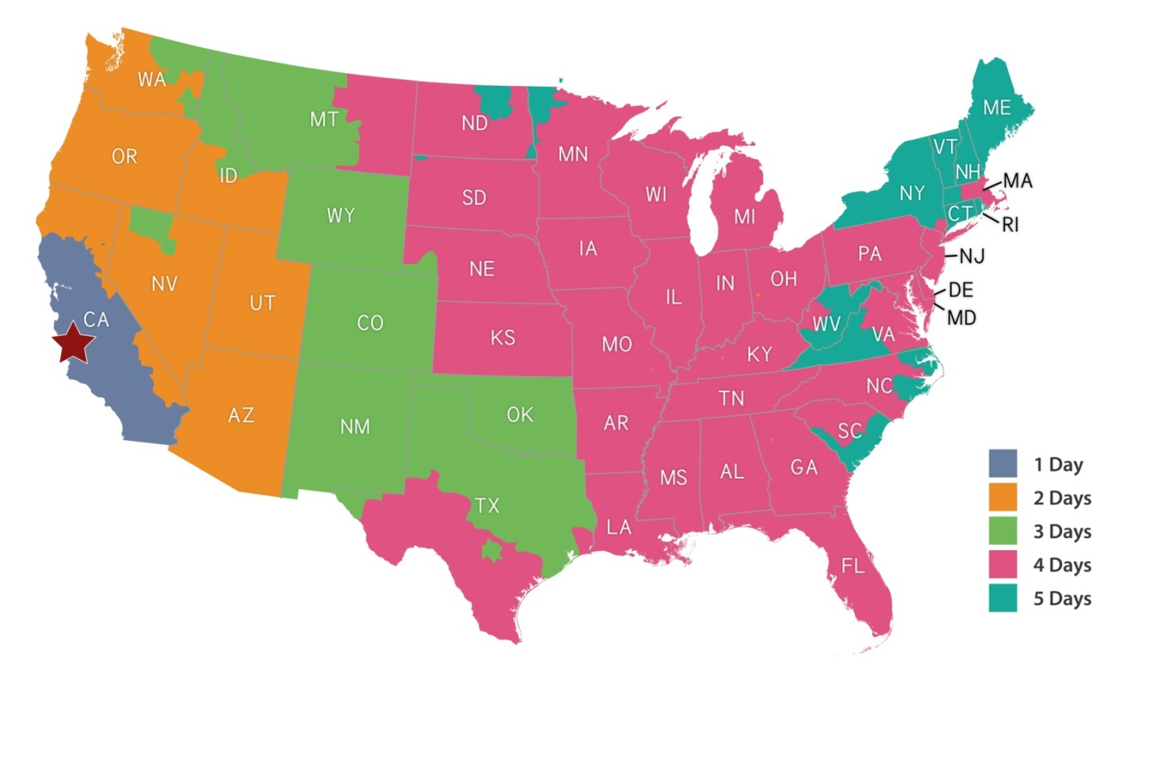
Time in Transit maps listed are for our preferred carrier UPS.

2017 HOLIDAY SHIPPING TIMELINES
From SANTA MARIA, CA (SMA)

HAPPY HOLIDAYS! In order to ensure a timely consumer delivery during the busy holiday season, we have provided recommended last order submission dates below for packages to arrive in time. During this busy season of the year, WineDirect will maintain our standard order cutoff time of 1pm to give you as much time as possible to process orders. Please note that carriers are suspending the guarantee of published transit times during the holiday peak times.
Below are the recommended LAST ORDER SUBMISSION DATES
to ship from the SANTA MARIA, CA facility:

SERVICE | TIME IN TRANSIT | THANKSGIVING | CHRISTMAS | NEW YEARS
Ground & Overnight | 1 Day | 11/20 | 12/20 | 12/27
Ground & 2-Day | 2 Days | 11/17 | 12/19 | 12/26
Ground | 3 Days | 11/16 | 12/18 | 12/22
Ground | 4 Days | 11/15 | 12/15 | 12/21
Ground | 5 Days | 11/14 | 12/14 | 12/20
Ground | 6 Days | 11/13 | 12/13 | 12/19
Ground | 7 Days | 11/10 | 12/10 | 12/18
WineDirect Holiday Hours |  | Closed 11/23  Open 11/24 | Open ½ Day 12/22  Closed 12/25 | Open ½ Day 12/29  Closed 1/1

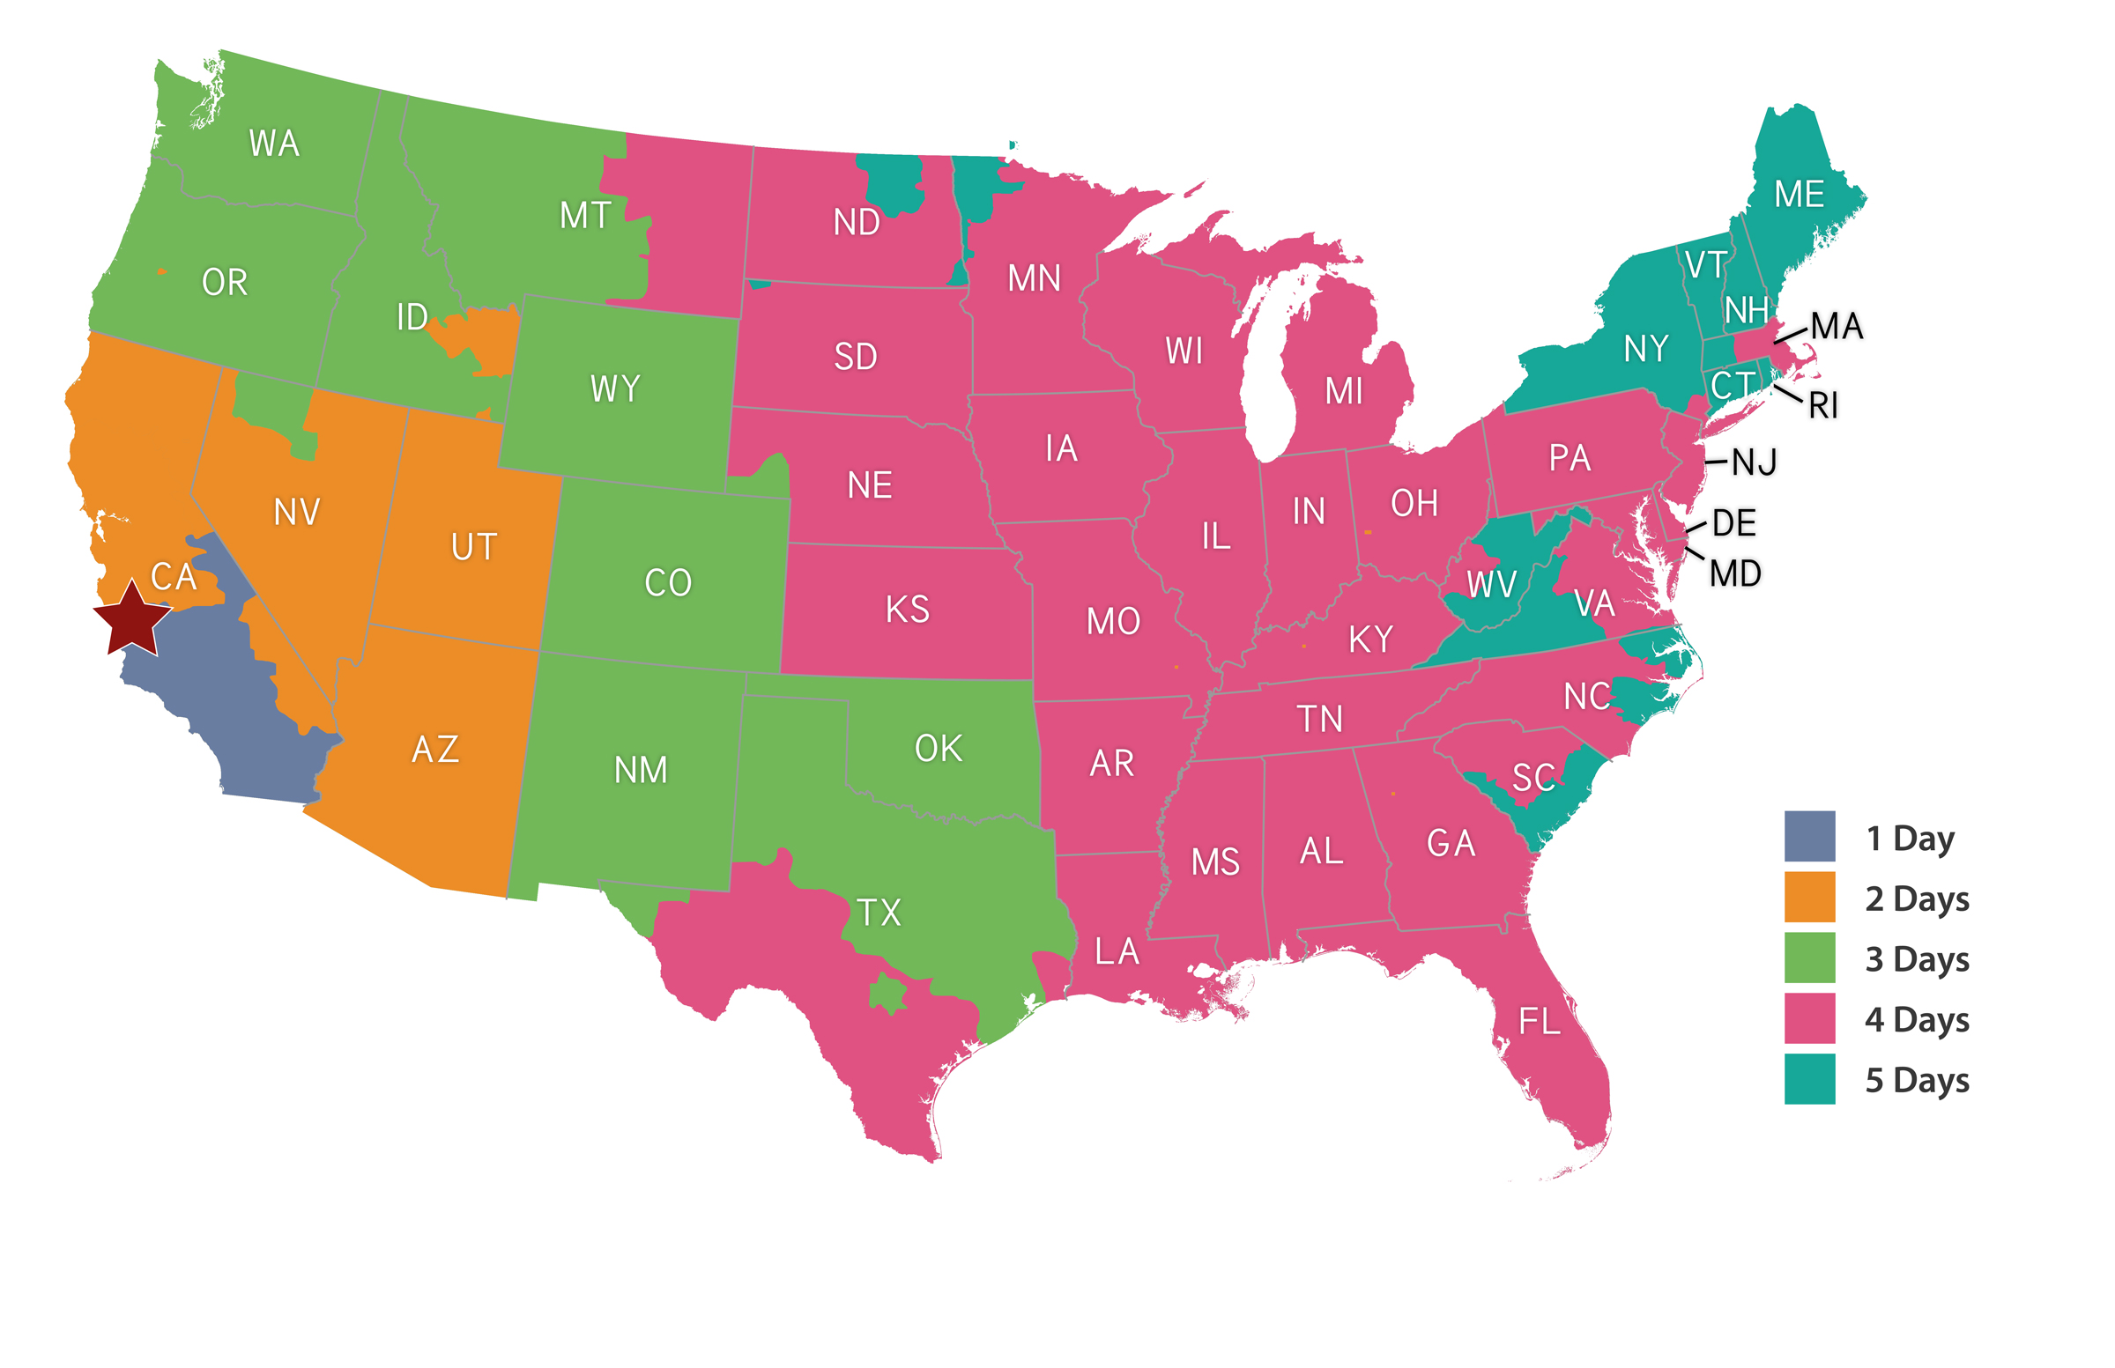
Time in Transit maps listed are for our preferred carrier UPS.

